# CS 255 System Design Document Template

## UML Diagrams

### UML Use Case Diagram

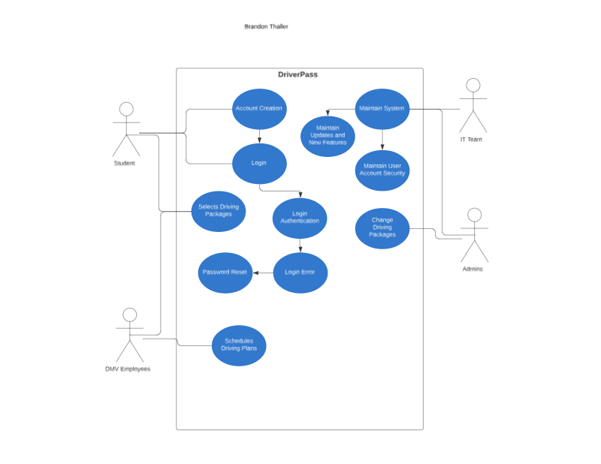

### UML Activity Diagrams

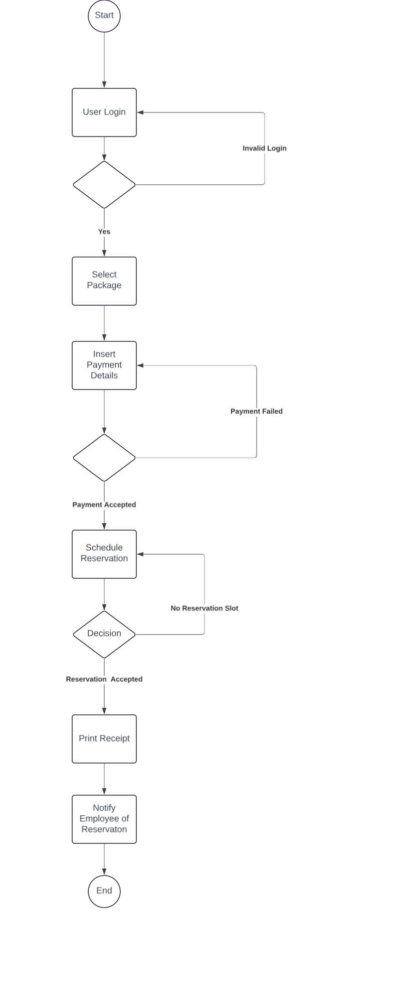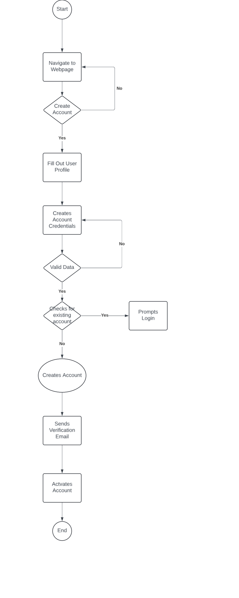

### UML Sequence Diagram

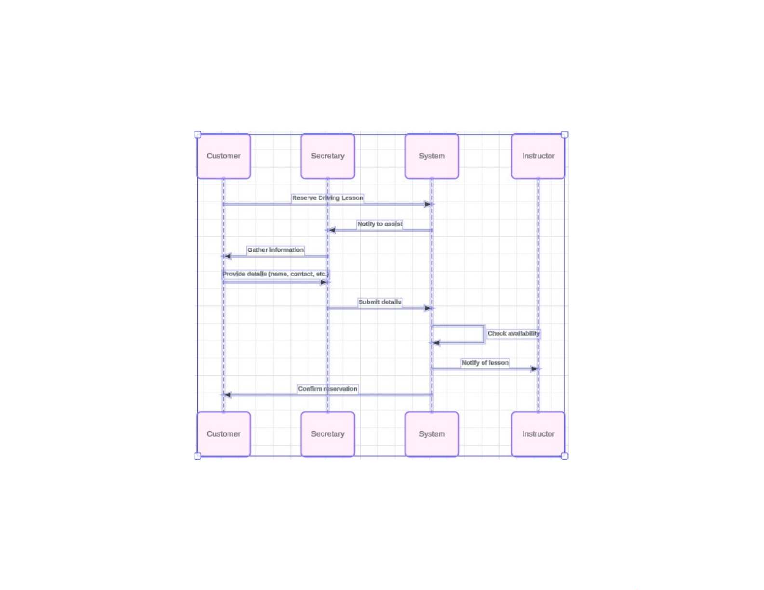

### UML Class Diagram

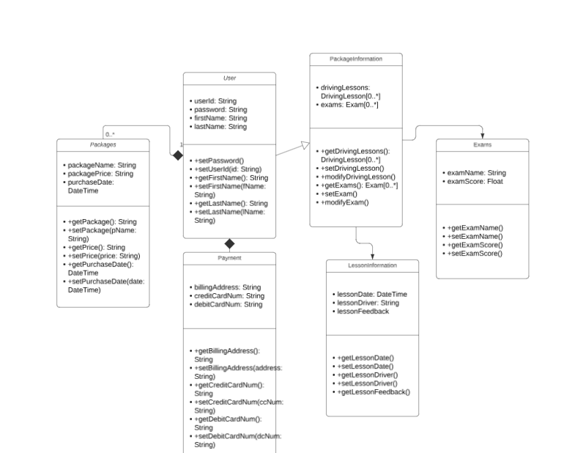

## Technical Requirements

To run the DMV service, we need:

* Powerful servers with fast processors, lots of memory, and plenty of storage.
* Modern computers or mobile devices with internet access for users.
* Software like Linux or Windows for servers, and browsers like Chrome or Firefox for users.
* Tools to build, test, and maintain the application, like Git for version control
* Security measures like firewalls, data encryption, and backup systems to keep everything safe and reliable.
* Easy-to-use and responsive design for all devices (desktop, tablet, mobile)
* Accessibility features for users with disabilities
* Ability to handle many users at once
* High availability with minimal downtime
* **Cloud Services:** (Optional for better scalability and redundancy)